Makerbot
Inventor

STLs and Makerbot Instructions
Objectives

Before beginning this module, you must have completed CAD Mechanical –
Part 1. The skills you developed earlier will be necessary for you to continue your AutoCad experience in this module.

In this assignment you will apply the circle, center mark, polar array, dimension radius, dimension diameter, and move location of dimension text commands along with commands previously learned.

Getting Started

- Open the drawing you want to print on the 3D printer.

Converting an .ipt Drawing to an STL File

- Click on the Inventor Icon in the upper left hand corner.

- Select Export, then CAD Format.

- Save the type as STL Files, Name your File, Navigate to your U: drive folder. DO NOT CLICK SAVE YET!

- Select Options

- Change Units to inch, then click OK and then Save.

MakerBot

- Open MakerBot through the Startup menu.

- Select Add File:

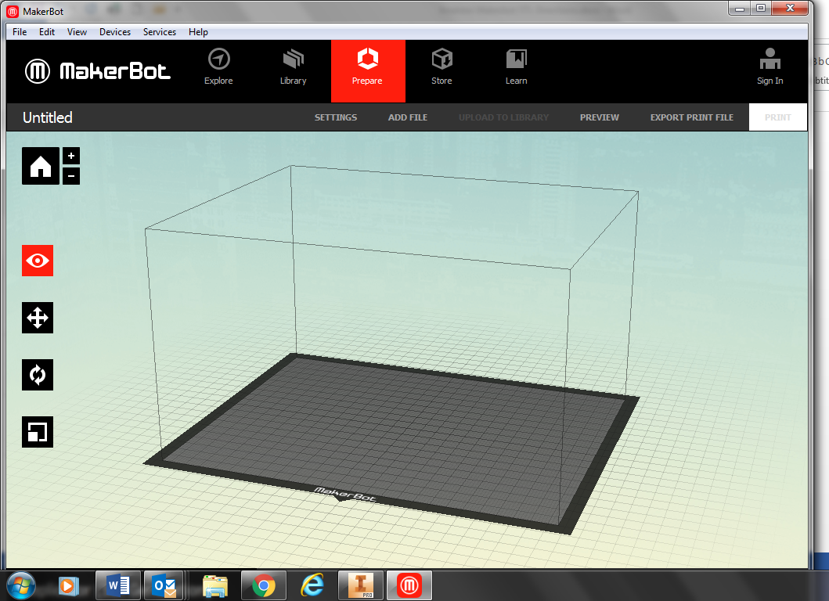

- Navigate to your STL file and click Open.

- Select Rescale Object:

- Make sure your object is positioned properly. Select the Rotate Objects icon:

- Select +90 and then Lay Flat. Note: This may or may not be the best option for your car. It depends on how you drew it in Inventor that determines the position it will appear. Make sure it object lays flat and is centered on the platform.

- Click the X to close out or the Rotation menu item.

- Select Settings.

- Make sure that Raft, and Support are checked.

- Change the number of shells to2and the layer height to 0.20.

- Click on the Custom Tab then select Infill:

- Change Infill to 40%. (This will make your car denser and use more material. The higher the density, the longer the print.) Click Okay until you are out of Settings.

- Select EXPORT PRINT FILE:

- Navigate to the flash drive folder and save it with your name and the part name. Note: Write the file name and date you saved it to the flash drive on the sheet of paper hanging on the wall behind the printer.

